
Intake Forms
Name __________________________
DOB ___________________________
Phone number ______________________
Email ___________________________________
Residence type & Address ____________________________
_____________________________________________________
Who do you live with? _______________________________
Occupation _______________________________
Valued hobbies ____________________________

List any and all health conditions _____________________________________________________
____________________________________________________________________________________
- I certify this is an accurate and complete account of my health conditions _________

List any surgeries you have had _______________________________________________________
____________________________________________________________________________________
- I certify this is an accurate and complete account of all surgeries _________

List any and all medications you are taking _____________________________________________
____________________________________________________________________________________
- I certify this is an accurate and complete list of all my medications _________

Mobility
What is your level of Mobility? (Wheelchair or other devices, walk with assistance, walk short distances, walk over a mile)
____________________________________________________________________________________
Do you experience frequent falls?
____________________________________________________________________________________

Pain
Do you experience pain on a daily basis? (Yes) (No)
Where is the pain located? Can you describe it? Besides pain, are there any other symptoms you are experiencing (e.g., numbness, tingling, weakness)?
____________________________________________________________________________________________________________________________________________________________________________________________________________________________________________________________
How long have you been experiencing chronic pain?
____________________________________________________________________________________
Have you received previous treatment for chronic pain? If so please provide details.
____________________________________________________________________________________
Have you had any imaging studies (X-rays, MRI, CT scans) related to your pain? If yes, please specify.
____________________________________________________________________________________
Are there any activities or movements that aggravate the pain?
____________________________________________________________________________________
What makes the pain better? What treatments are you currently receiving for pain?
____________________________________________________________________________________
What is the pain at its worst? (0-10) _______
What is the pain at its best? (0-10) _______
Please mark all areas of pain in the images below

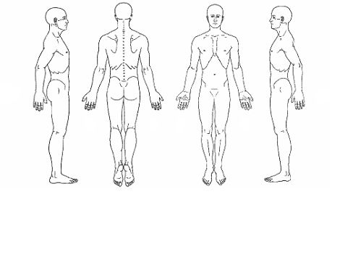

Addiction
Do you have concerns about substance use? (alcohol, tobacco, prescription or recreational) If so please explain, or we can discuss in person if you are more comfortable.
____________________________________________________________________________________
Mental Health
Is stress a major problem for you?
____________________________________________________________________________________
Do you feel depressed often?
____________________________________________________________________________________
Do you have problems with eating or your appetite?
____________________________________________________________________________________
Do you have trouble sleeping?
____________________________________________________________________________________

Occupational history
What are you currently not doing, or having difficulty with, that you would like to do more/better?
____________________________________________________________________
____________________________________________________________________

What prevents you from doing the things you want to do?
____________________________________________________________________

What gives you a sense of purpose and meaning? What do you believe could give you a sense of purpose and meaning?
____________________________________________________________________

Additional Comments
Is there any other information you would like us to know about your chronic pain or medical history?
________________________________________________________________________________________________________________________________________________________________________

Consent
I hereby authorize the healthcare provider to review my medical records and perform necessary assessments to evaluate and treat my chronic pain.
Signature __________________________________
Date ______________________________________

Thank you for completing this form. I look forward to assisting you with your pain management plan.

